Architecture

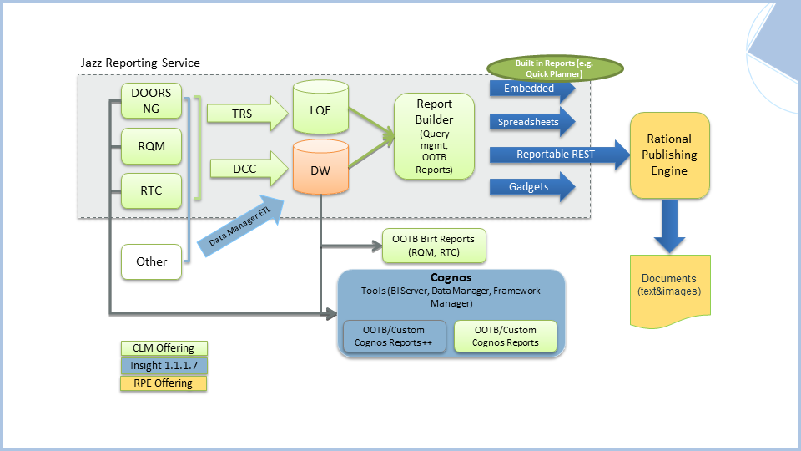

**What is LQE ?**

The Lifecycle Query Engine (LQE) implements a Linked Lifecycle Data Index over data provided by one or more lifecycle tools.

A lifecycle tool makes its data available for indexing by exposing its Linked Lifecycle Data via a Tracked Resource Set, whose members MUST be retrievable resources with RDF representations, called Index Resources.

An LQE Index built from one or more Tracked Resource Sets allows SPARQL queries to be run against the RDF dataset that aggregates the RDF graphs of the Index Resources. This permits the data from multiple lifecycle tools to be queried together, including cross-tool links between resources. Changes that happen to Index Resources in a lifecycle tool are made discoverable via the Tracked Resource Set's Change Log, allowing the changes to be propagated to the Lifecycle Index to keep it up to date.

**Lifecycle Query**

Provides ability to run queries over linked lifecycle data aggregated from multiple lifecycle tools

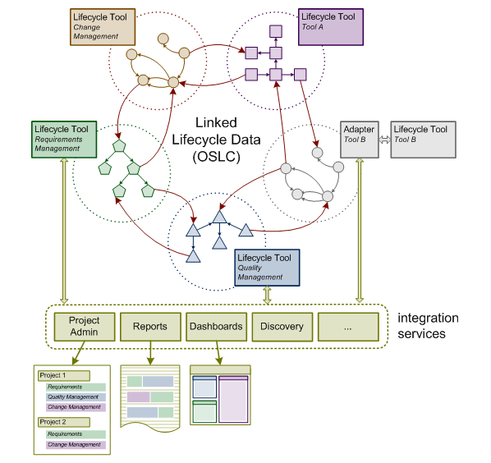

**Linked Lifecycle Data (LLD) Providers**

Tools declare LLD sources for indexing purposes

Tool provides Tracked Resource Set (TRS) resource

Base – list of resources having RDF content

Change log – list of resources recently added, deleted, or changed

Patches – list of simple property modifications

Tools include an Access Context triple in resources as specified Indexable Linked Data Source specification

**Tracked Resource Set (TRS) Resource**

* A GET-able resource e.g. http://cm1.example.com/trs
* of type (rdf:type) http://open-services.net/ns/core/trs#
* that refers to a base resource e.g. http://cm1.example.com/base using trs:base predicate
* and to a change log resource using trs:changeLog predicate

# Resource: http://cm1.example.com/trs

@prefix trs: <http://open-services.net/ns/core/trs#> .

<http://cm1.example.com/trs>

a trs:TrackedResourceSet ;

trs:base <http://cm1.example.com/base> ;

trs:changeLog [

a trs:ChangeLog ;

trs:change ... .

] .

**Base Resource**

* A GET-able resource e.g. http://cm1.example.com/base
* that refers to members of a tool’s Resource Set using rdfs:member predicates
* and has trs:cutoffEvent predicate with URI of the most recent Change Event that is already reflected in this Base, as its value

# Resource: http://cm1.example.com/base

@prefix trs: <http://open-services.net/ns/core/trs#> .

@prefix rdfs: <http://www.w3.org/2000/01/rdf-schema#> .

@prefix ldp: <http://www.w3.org/ns/ldp#> .

<http://cm1.example.com/base>

a ldp:Container;

trs:cutoffEvent <urn:urn-3:cm1.example.com:2010-10-27T17:39:31.000Z:101> ;

rdfs:member <http://cm1.example.com/bugs/1> ;

rdfs:member <http://cm1.example.com/bugs/2> ;

rdfs:member <http://cm1.example.com/bugs/3> ;

...

rdfs:member <http://cm1.example.com/bugs/199> ;

rdfs:member <http://cm1.example.com/bugs/200> .

**Change Log**

* A set of Change Events
* Where each Change Event is a resource of type trs:Creation or trs:Modification or trs:Deletion
* and refers to a changed resource e.g. http://cm1.example.com/bugs/23 using trs:changed predicate
* and has an order reflecting the sequence in time of the Change Event

<http://cm1.example.com/trackedResourceSet>

a trs:TrackedResourceSet ;

trs:base <http://cm1.example.com/baseResources> ;

trs:changeLog [

a trs:ChangeLog ;

trs:change <urn:urn-3:cm1.example.com:2010-10-27T17:39:33.000Z:103> ;

trs:change <urn:urn-3:cm1.example.com:2010-10-27T17:39:32.000Z:102> ;

trs:change <urn:urn-3:cm1.example.com:2010-10-27T17:39:31.000Z:101> .

] .

<urn:urn-3:cm1.example.com:2010-10-27T17:39:33.000Z:103>

a trs:Creation ;

trs:changed <http://cm1.example.com/bugs/23> ;

trs:order "103"^^xsd:integer .

<urn:urn-3:cm1.example.com:2010-10-27T17:39:32.000Z:102>

...

TRS

TRS consists of several OSLC resources (TRS resources) to describe information for TRS:

1 Tracked Resource Set

2 Base

3 Change Log

4 Change Event